**Matthew Diaz**

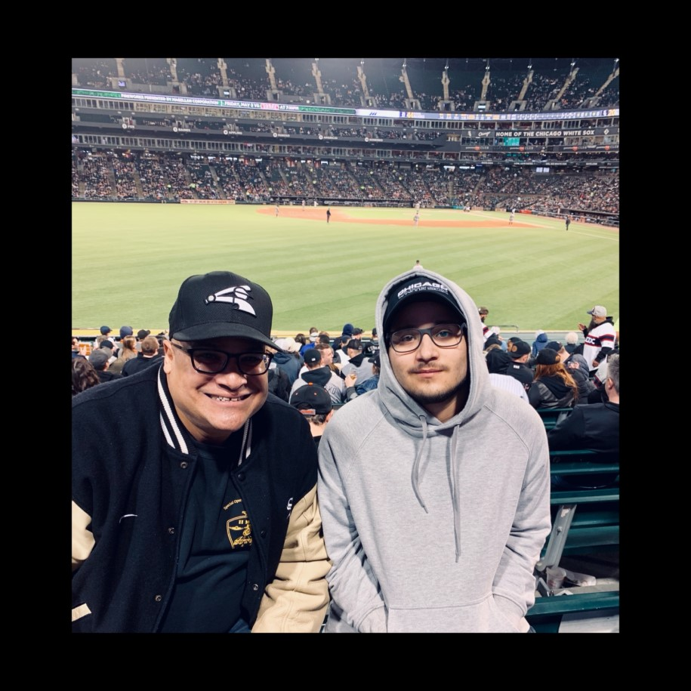

I value authenticity and respect. I believe that everyone should be respected unless given a reason not to be. I don’t believe in lying and try to be as straightforward as I can.

As far as interests, I enjoy being with friends, basketball and baseball, I am a big fan of music and film as well as playing video games in my free time.

For my career I am looking to enter the field of cyber security. It is a growing field that interests me because of its importance in the world that we live in today

In this course I look forward to learn more about programming as well as skills that will help me in my future career.